**INDIVIDUAL**

# How to create an Individual

* To create an individual membership.

Choose option **“BA”** INDIVIDUAL.

Choose option **“AA”** SUBSCRIBER/DEPENDENT

Give a random ID and choose option **“AA”** ADD ENROLLMENT

* Give the contract no and effective date. After getting the contract details **press F10**

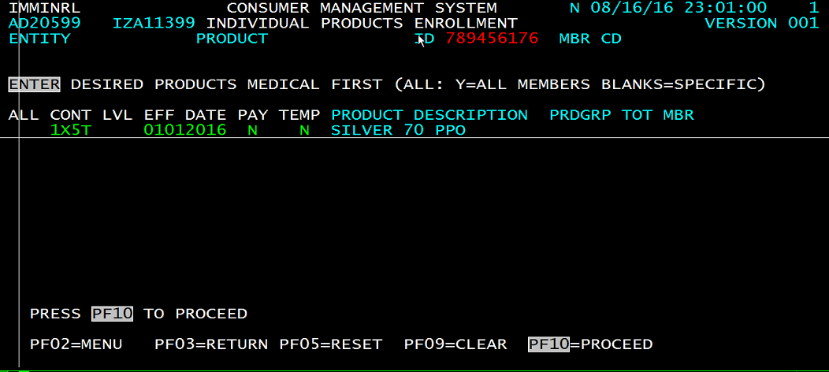

* Give the home address, state, zip, bill frequency, on-line as N, converted business as N. **Press F10**

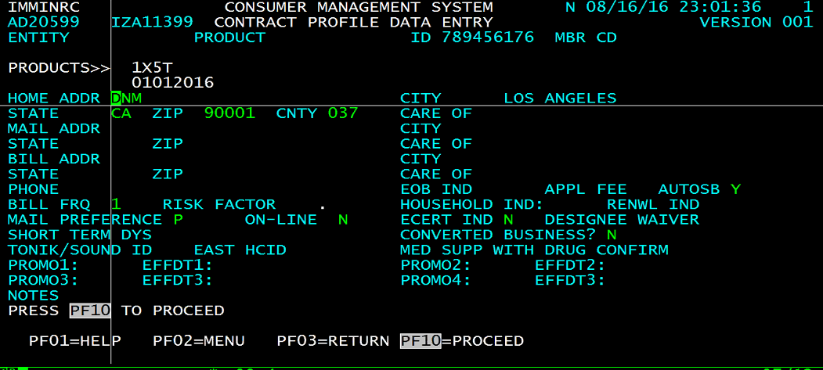

* Member profile. Give the demographics information for the member. **Press F10**

**Check the sex code**

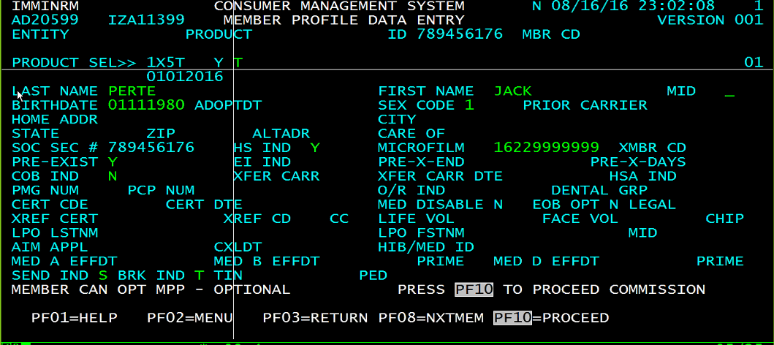

* Give the tin no and other details and **press F10**

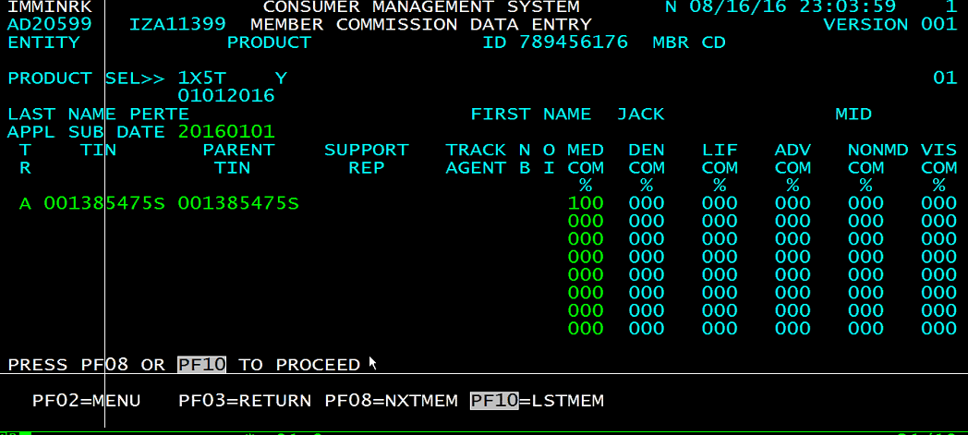

* Give Enter and F10 in the below screen

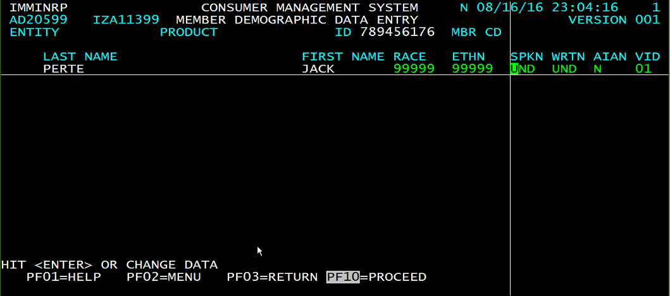

* Give Enter and F10 in the below screen

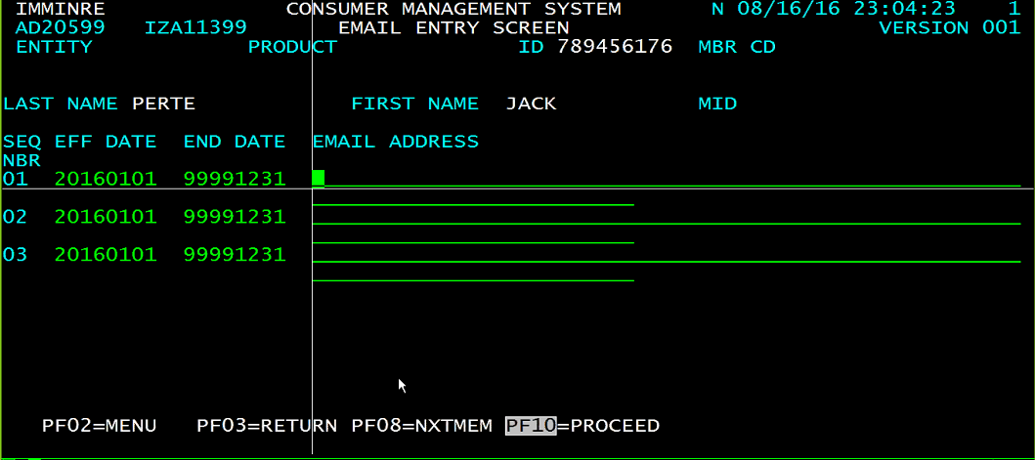

* Give the Id no and change the rate **QT MBR RT. Press F10**

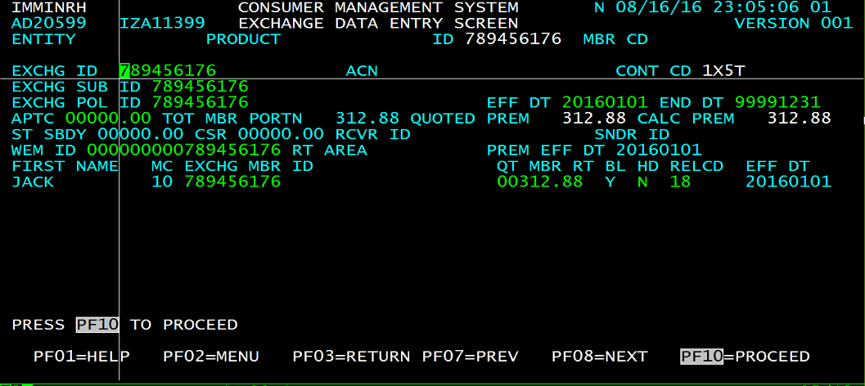

* Press F10

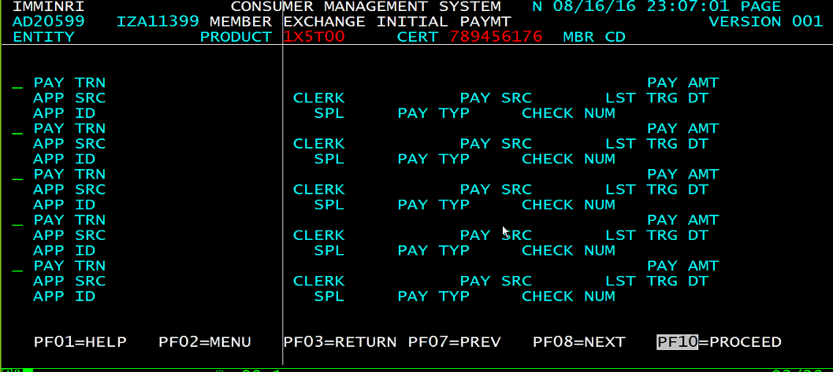

* If HCID is populates and billing rate created message has been shown, that means member is created.

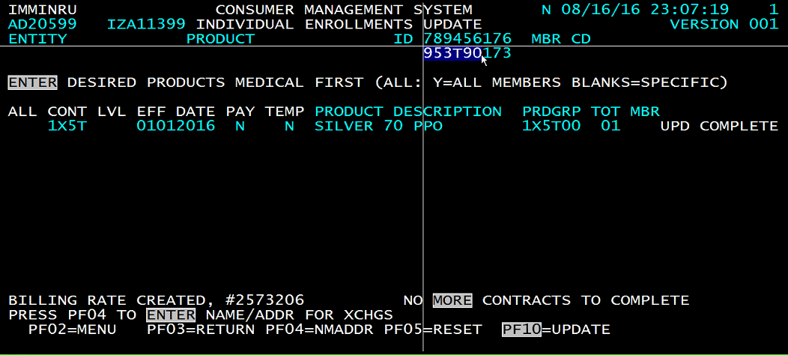

**Billing and Reconciliation for INDIVIDUAL**

* Choose option “**BA** – INDIVIDUAL”
* Choose option “**DA** - BILLING & RECON”
* Give the member id and Choose option “**BA** - REQUEST RECEIVABLE”
* In INDIV/SENIOR REQ REC screen give selection code as **“01”** and enter + F10

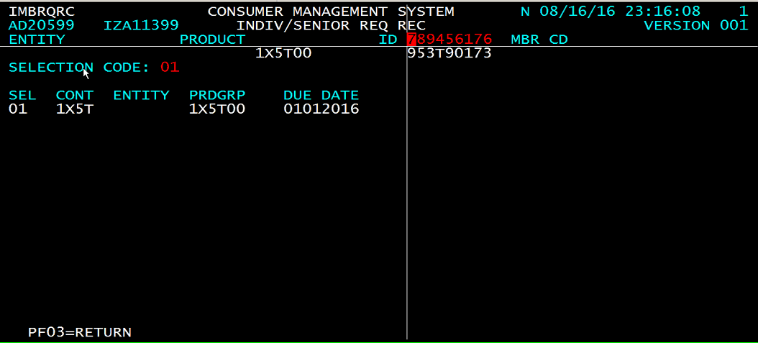

* Now you need to decide for how many months you want to request bills. As per your need give the months in BILL MONTHS, Enter and F10.

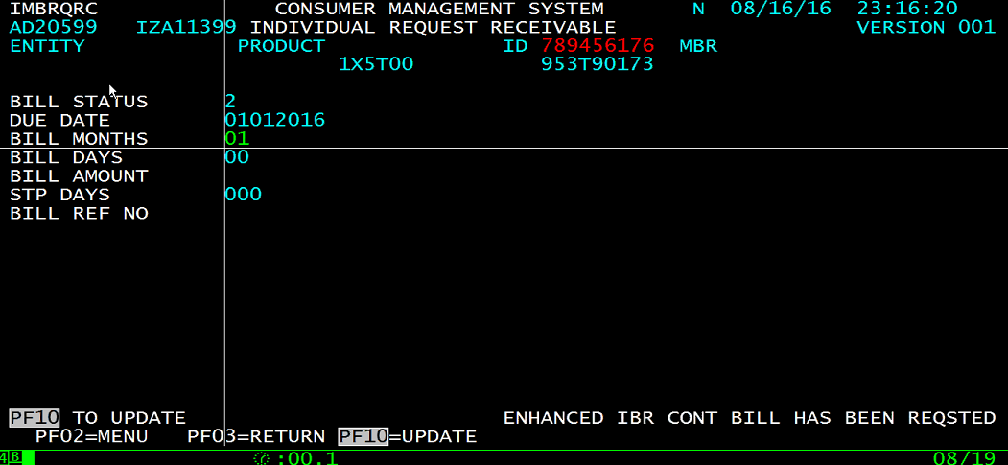

* Now to pay the bill. GOTO **“EA - CHECK SYSTEM”** option. It will take you to below screen. Then you have to do is **“AC - CHECK BATCH ENTRY”**

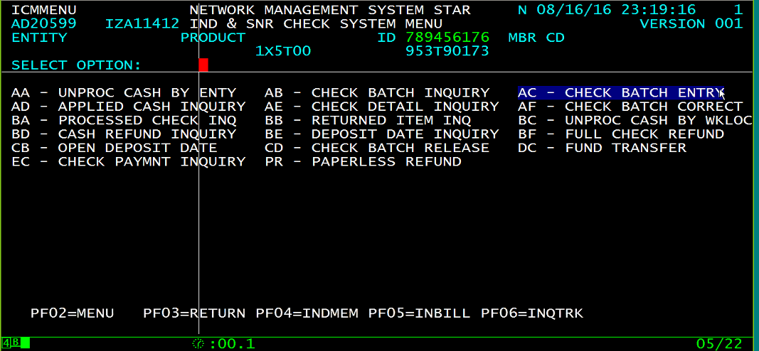

* Give the appropriate MBU (like for CA – CAB and if it is individual give “I” and if it is small group then “g” like CABG). Paste the Due amount in CHK AMT field. Give the member no in BATCH ID/INDIV field and give product in GROUP field else if it is small group give ENTITY. For other fields give random values and F10.

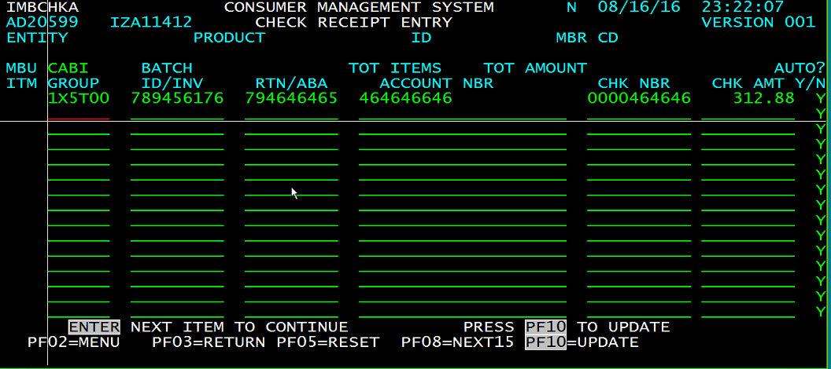

* **Copy the Batch no.** It is difficult to get the no.

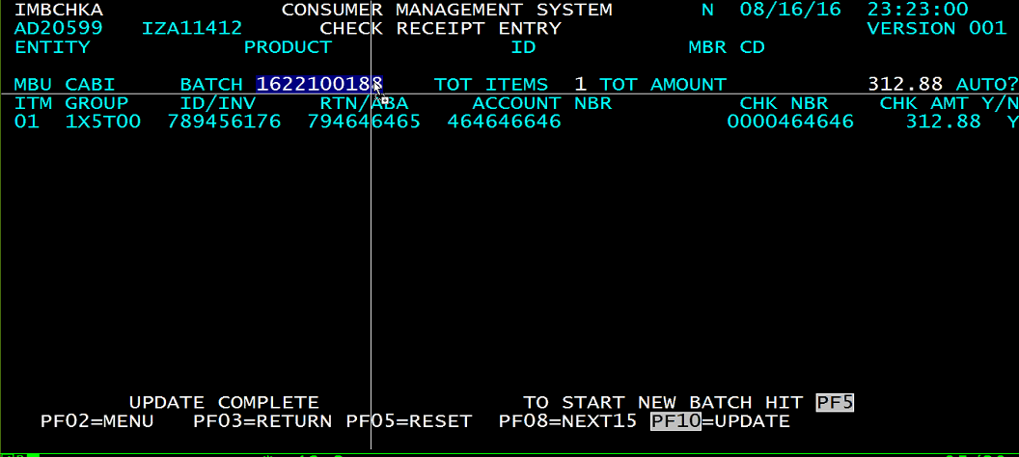

* After getting the batch no, now we have to release the batch.

F3 and choose option “**CD** - CHECK BATCH RELEASE”.

* Give the STATE, MBU and BATCH details and F10. With this check batch release is completed now we have to reconcile it.

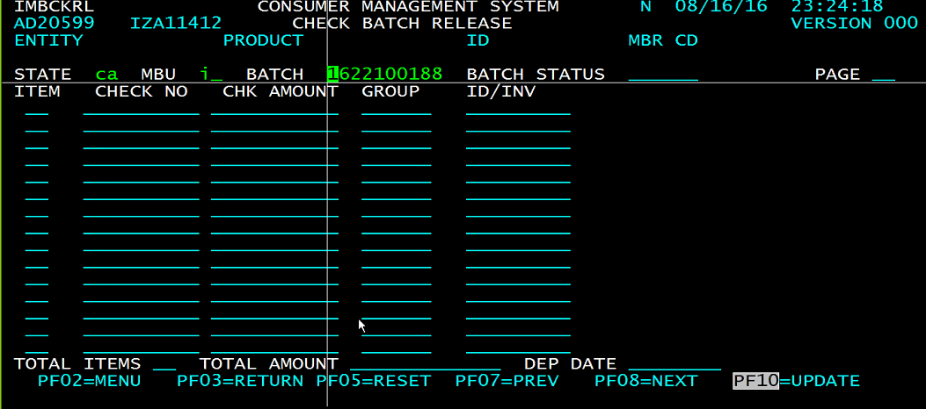

* GO BACK and choose option “**AA** - UNPROC CASH BY ENTY”. In the below screen if the status is UNPROC, we need to reconcile it. Press F9

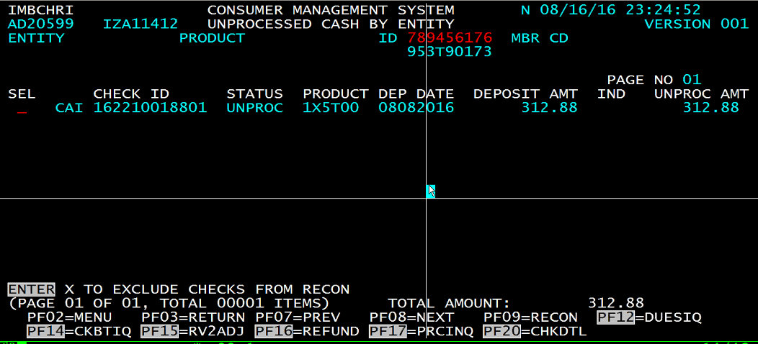

* In the below screen hit enter and F10. With this reconcilement is completed.

